MongoDB-Sharding

1. Adding shards clusters from Mongos

Screenshot of adding shard cluster for Shard1 from Mongos shell

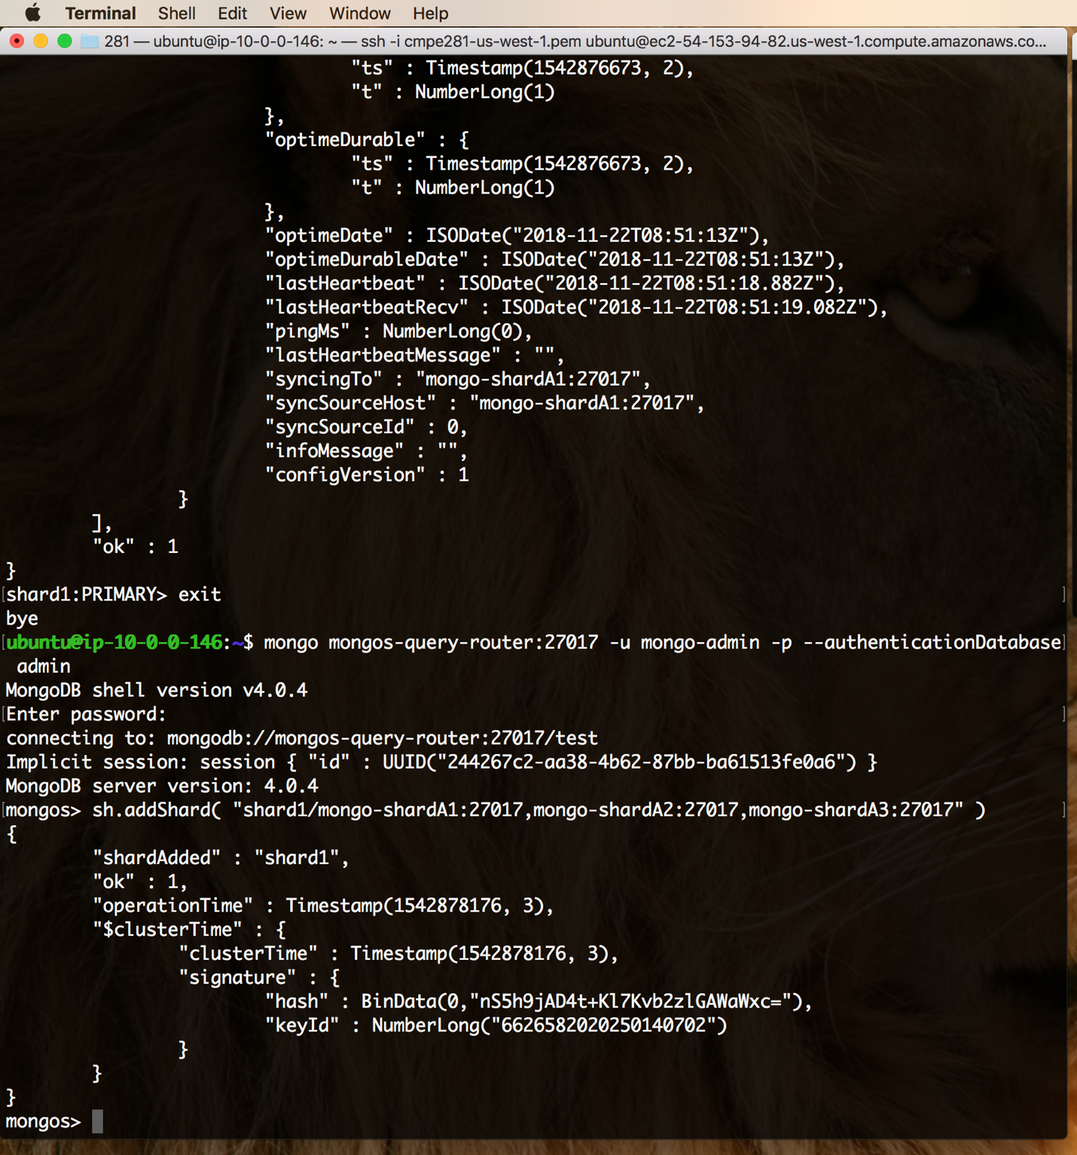

Screenshot of adding shard cluster for Shard2 from Mongos shell

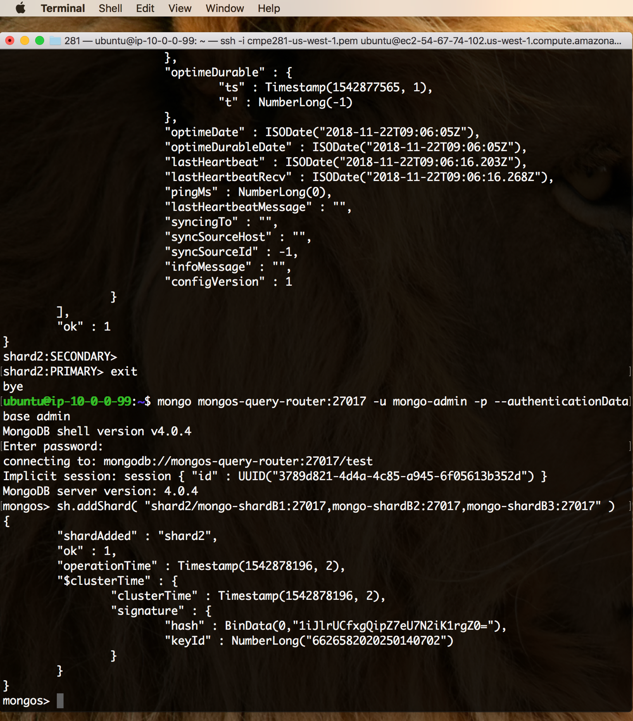

Using enableSharding() method enabling the shards at database level

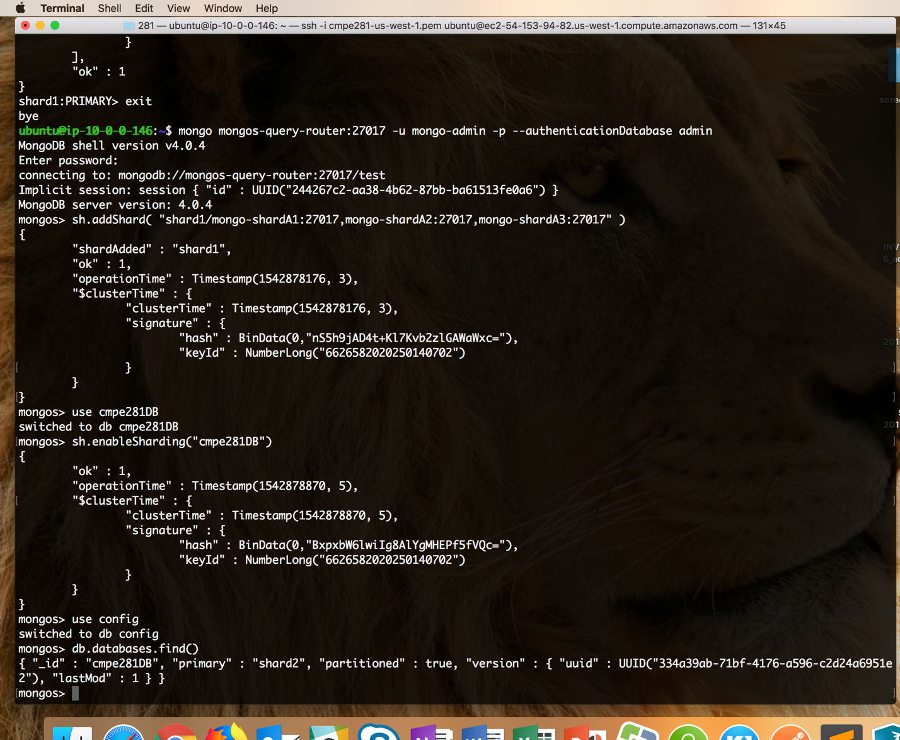

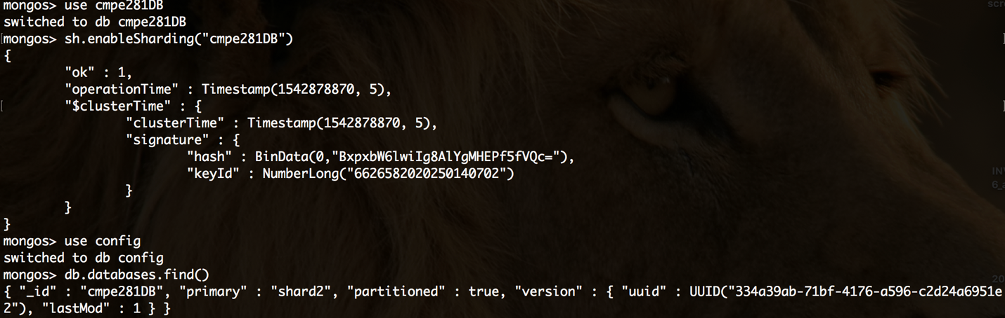

Now inserting some data into the database that we created

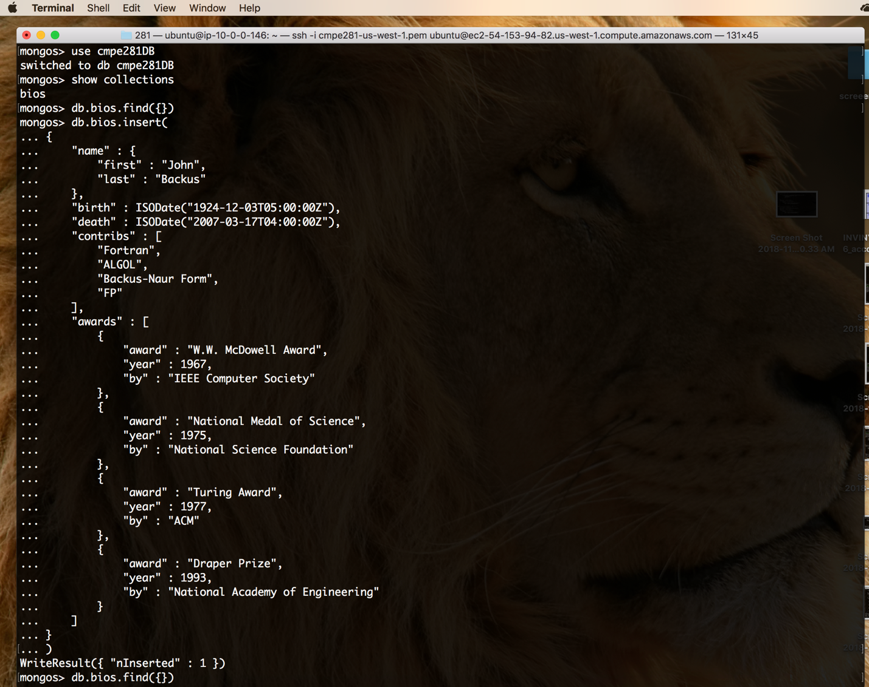

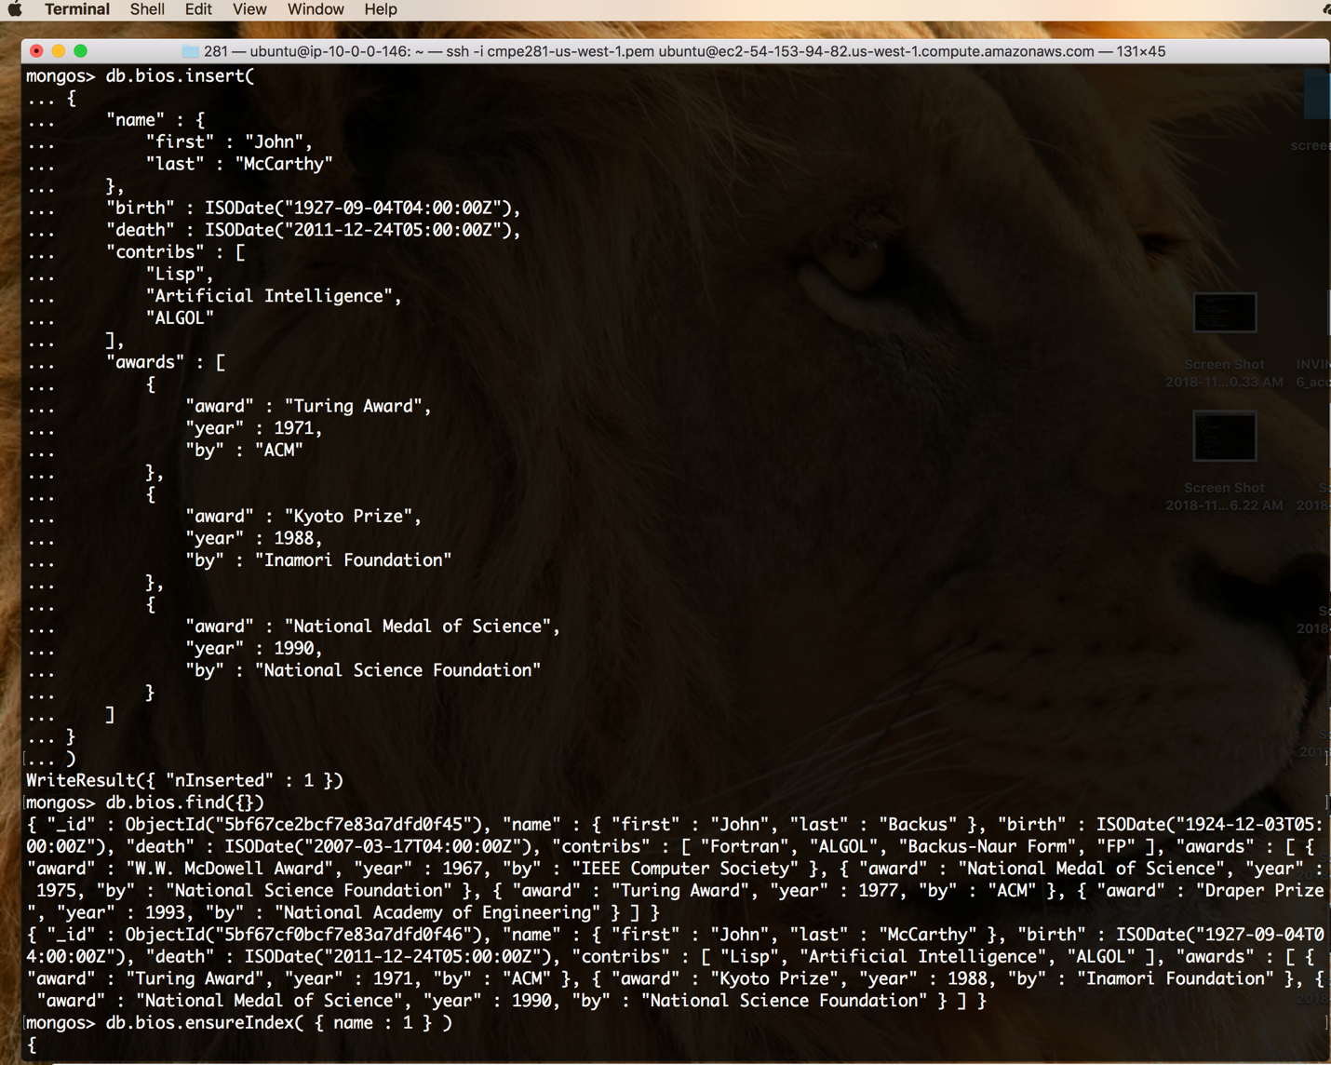

Now as we have 2 data inserted into out bios collection, we are creating a index for out shard key

Using name key as the shard key as it will be easy to distribute the data so that same name or same first letter names will be collected together in one shard and easy to query the database.

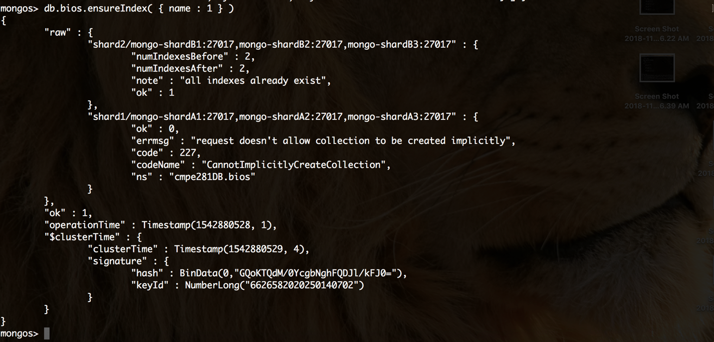

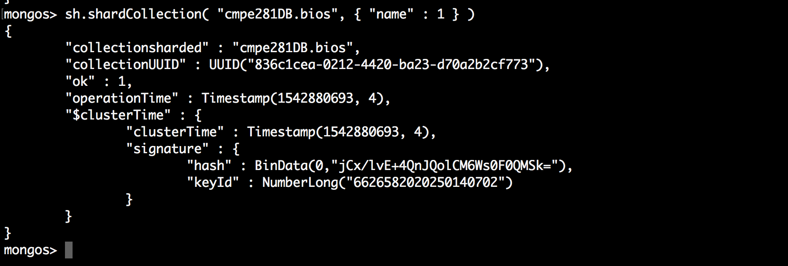

When you do getShardDistribution() then you will get that shard2 is having 100% of the data because MongoDB only does balancing of data among shards whren the number of chunks is greater than 20 and migration threshold is 2.

As we only have 10 records in Bios collection. All the data went to shard2 cluster. When the records will increase then the data distribution will be done among shards

Available at- <https://docs.mongodb.com/manual/core/sharding-balancer-administration/#sharding-migration-thresholds>

